# **Self Portrait – Painting at Pigeon Cove, Rockport**

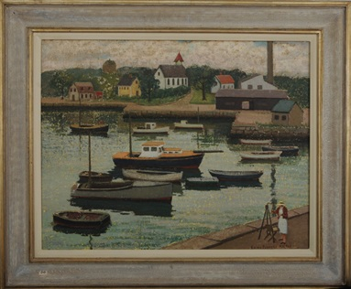

**Emma’s Signature**

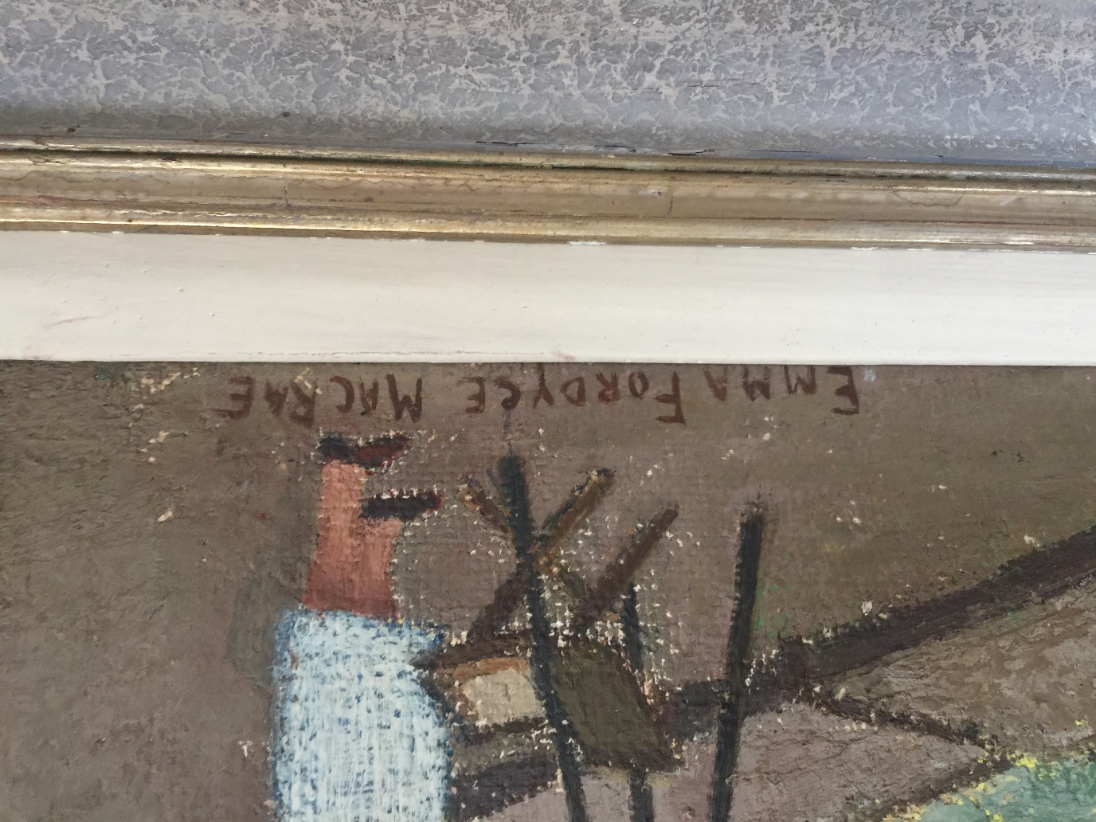

**Labels on rear of painting**

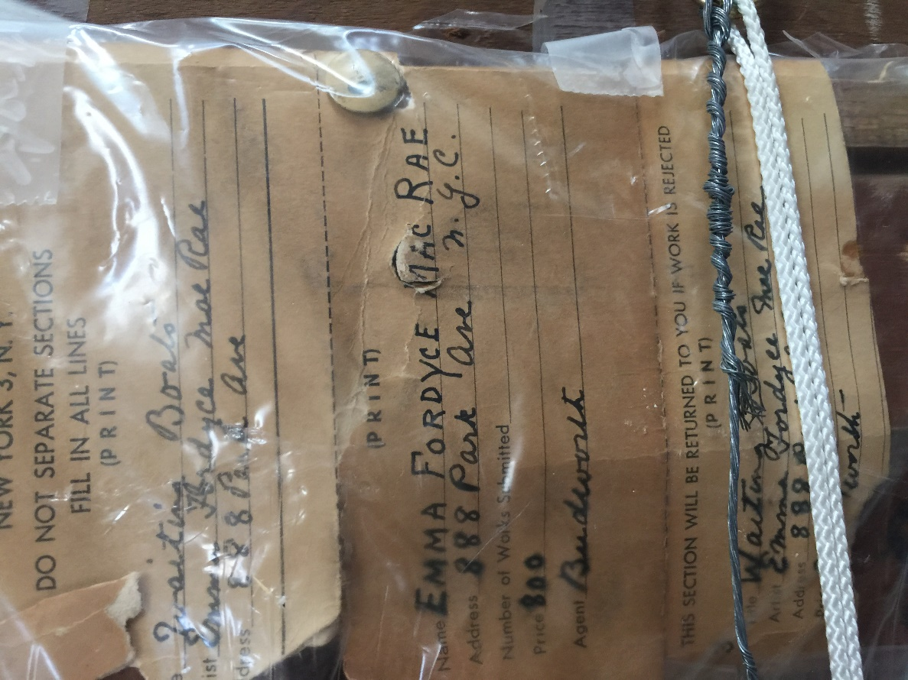

**Rear of painting**

